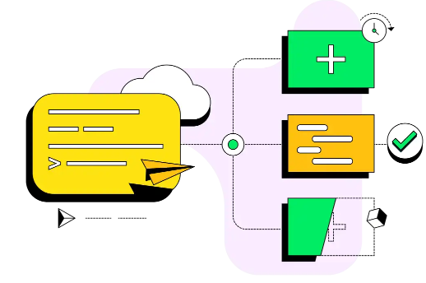

**Run Instructions for MongoDB Dashboard**

Table of Contents

Table of Contents 1

1. Revision History 2

2. Option 1 – Connection using MongoDB Compass (GUI) 3

3. Option 1 cont- and Option 2 – Connecting using Mongosh (shell) 4

4. Option 2 cont- 5

5. Environment Setup (Jupyter Notebook) ………………………………………………………………6  
6. Environment Setup cont & required packages………………………………………………………7

## Document Revision History

| **Version** | **Date** | **Author** | **Comments** |
| --- | --- | --- | --- |
| 1.0 | 7/26/2025 | Matthew Guarino | Rough Draft |
| 1.1 | 8/1/2025 | Matthew Guarino | Title page, table of contents, document revision history, have been added. Screenshots of CMD prompts & mongo compass added. Added two options for connecting to database opt1 & opt2 |
|  |  |  |  |

**Guide to set up MongoDB Dashboard Environment**

This guide explains how to set up and run the MongoDB Dashboard locally, using a virtual environment and Jupyter Notebook. These are the exact steps used to launch the application in a Windows environment.

There are two ways that you can connect to the database:

* + Using MongoDB compass (GUI Version)
  + Using Mongosh (Command line prompt)

**Option 1 - MongoDB Compass Connection**

Before running the dashboard:

* Open **MongoDB Compass**
* (Install it if not already installed: <https://www.mongodb.com/try/download/compass>)
* Under **Host Name**, enter or select:
  + Project-Capstone
* Click **Connect**

Once connected, ensure the database AAC and collection animals are visible and contain ~50–100 documents.

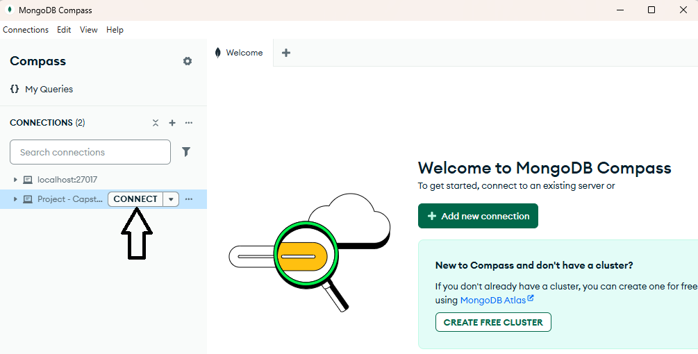

After a successful connection you should be able to see the contents of the animals collection. All 10.0 k “animals” have been successfully imported.

**Option 2 – Using Mongosh Shell (Command Prompt)**

1. If not already installed here is the link to download mongosh shell
   * <https://www.mongodb.com/try/download/shell>
2. Once downloaded you must extract all of the files into a folder on your (C: Drive)
   * Preferably in your Program Files, like below

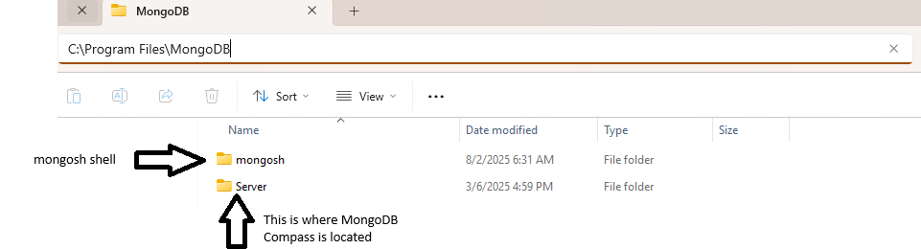

1. Make sure your system variables are set up so it can run the mongosh shell in the command prompt.
2. Open Environment Variables
   1. Press Windows + S, type Environment Variables, and select “Edit the system environment variables”
   2. In the System Properties window, click “Environment Variables…”
3. Edit the PATH Variable
   1. Under System variables, find Path and click Edit
   2. Click New and paste this:
4. In my case in was in this path
   1. C:\Program Files\MongoDB\mongosh\mongosh-2.5.6-win32-x64\bin
5. Apply changes: Click OK on all windows to save and exit
6. Test it out and make sure the command works correctly
   1. You don’t have to be an administrator to try the command.

A successful installation of mongosh shell and connecting to the AAC database shown below

**🧰 Environment Setup (Jupyter Notebook)**

I created a dedicated folder for the dashboard environment and placed it into my C: drive

C:\dash_env

1. Go to the command prompt 🡪 right click on it and RUN as Administrator.
2. Used the cd command to get into the dash_env folder
   1. cd \dash_env
3. Run the activation script
   1. Venv\Scripts\activate
      1. You should see exactly this: (venv) C:\dash_env>
4. Type: jupyter notebook
   1. Your command prompt will look like the image below and a internet browser will pop up showing you the Jupyter Notebook home screen.

1. Once you get to the home page click: ProjectTwoDashboard(1).ipynb
   1. You see the code for the dashboard. When scrolling down, you see initially see an error. Disregard that
2. Highlight the cell and click the RUN bottom
3. The dashboard will appear at the bottom of the code block
   1. If you want to open it in a separate window, click the link <http://127.0.0.1:8050>
   2. Another tab will open up with just the dashboard.

**Required Packages**

* Dash
* Dash-leaflet
* Jupyter-dash
* Pandas
* Plotly
* Numpy
* matplotlib